 | Sense hat | 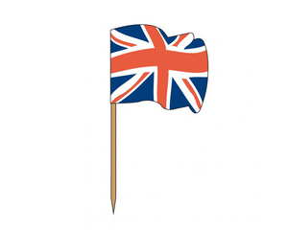  

Welcome to Raspberry Pi classroom. Let’s study the main board hardware, the sense hat shield and the multiplexed display.

1 Inside RPI | - RPI improvements.  - ARM, RAM, WIFI and current consumption
2 Sense Hat sensors | - MEMS  - ISS  - Sensors
3 Sense hat display | - RGB leds  - Multiplexed display  - Current calculation
4 Sense hat programming | - C language comment

1 Inside RPI

https://medium.com/@ghalfacree/benchmarking-the-raspberry-pi-3-b-plus-44122cf3d806

  - What is the most important improvements for the new Raspberry Pi ?
Heat better distributed over the card

  - Define ARM architecture and its advantage
The ARM architecture is used to create chips for systems

  - How much RAM memory does RPI support ?
256 Mb

  - What is WiFi adapter data rate ?
5 GHz

  - What do the letters b/g/n means in 802.11b/g/n ?
https://en.wikipedia.org/wiki/IEEE_802.11

These are the letters behind the 3 versions of IEEE 802.11

  - What is a benchmark ?

It is a comparison of components / devices of the same type

  - Comment on ethernet benchmark

It's a comparison of two chips to see which performs better in Ethernet

  - What can you say about the current consumption ?

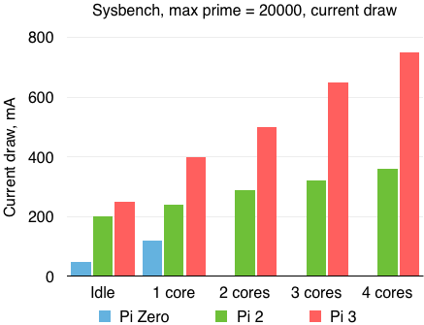

This increases depending on the version of the Pi

  - Do you have an RPI ? Is it easy to implement ? (5 lines min)

No I do not have any. But I know it's pretty easy to use, from the experiences I've heard
2 Sense Hat sensors

2.1 Explain MEMS acronym
https://www.youtube.com/watch?v=i2U49usFo10

Micro Electro-Mechanical System are very small electrical systems implemented in telephones and which can be used for several things, here it is used for detecting the movement of the telephone

2.2 Using « Essentials_SenseHAT_v1 light.pdf », what does Tim Peake do with the RPI in the space station ?

He used it to test codes created by children

2.3 Using annex 1, list all sensors embedded on Sense HAT

There is a gyroscope, an accelerometer, a magnetometer, a barometer, a temperature sensor, a relative humidity sensor, a 8x8 LED matrix display, 5 small joystick buttons, standoffs may come in plastic or metal varieties

2.4 Is it possible to know the altitude with a pressure measurement ?

https://www.mide.com/pages/air-pressure-at-altitude-calculator
Yes, it’s possible

2.5 Imagine that you climb 20 meters high, what will the pressure difference be ?
Pressure at Sea Level : 101325 Pa, Temperature : 15 °C

101084.97 Pa

2.6 Can a Sense hat measure this pressure difference ?

Yes with his sensors
3 Sense hat display

3.1 How many leds are on the Sense hat ?

There are 64 LEDs

3.2 summarize the video
https://www.youtube.com/watch?v=Hbxy1W9O_Wk

3.3 Why does sens hat use RGB LEDs ?

Because these are represented by decimal characters

3.4 Using annex 2,Why it is essential to use a Multiplexed display ?

This is essential so that, if one LED fails, the others are not affected.

3.5 Which switches must be closed to turn on led 9 ?

2 switches

3.6 Using annex 3, how can all the leds (L1 to L12) be lit simultaneously?

7 switches

3.7 Calculate the current consumed by 64 sense hat RGB leds. (detail your calculation)

One led consume 5mA, so 64 consume 320mA
4 Sense hat programming

Could you explain what the program do ?

The program ensures that as long as the 'enter' key is not pressed, all the LEDs of the matrix light up in blue then go out after 20 seconds
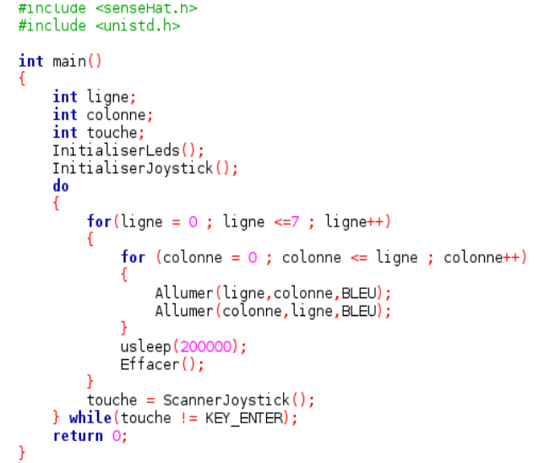

Annex 1

Sense hat Technical Details
- Gyroscope
  - Angular rate sensor (dps): ~245/500/2000
- Accelerometer
  - Linear acceleration sensor (g): ~2/4/8/16
- Magnetometer
  - Magnetic sensor (gauss): ~4/8/12/16
- Barometer: 260 - 1260 hPa absolute range (accuracy depends on the temperature and pressure, ~0.1 hPa under normal conditions)
- Temperature sensor: Accurate to ~2°C in the 0-65°C range
- Relative humidity sensor: Accurate to ~4.5% in the 20-80%rH range, accurate to ~0.5°C in 15-40°C range
- 8x8 LED matrix display
- Small 5 button joystick
- Standoffs may come in plastic or metal varieties
Product Dimensions: 65.1mm x 56.6mm x 13.9mm / 2.6" x 2.2" x 0.5"
Product Weight: 20.4g / 0.7oz

Annex 2

Multiplexed display – the basics

Multiplexing is a technique used to connect devices – typically LEDs (for displays) or buttons (for keyboards) – in a matrix of addressable rows and columns. The advantage is simplification of hardware due to the reduced number of pins required. Multiplexed displays using seven-segment LEDs remain popular due to low cost and high brightness.

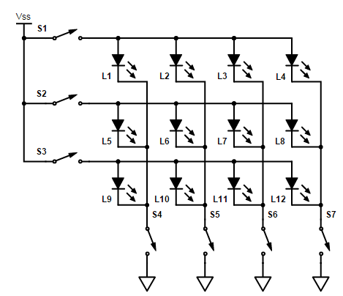

Figure 1. An LED matrix display. Each LED can be turned on individually by closing the appropriate row and column switches. In practice some form of current limiting is required.

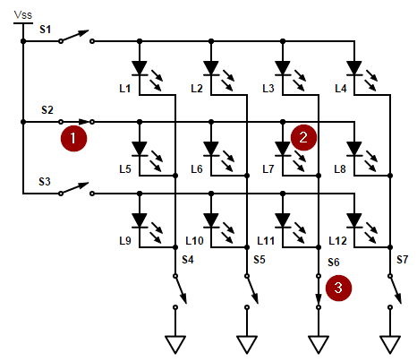

Figure 2. By closing switches 2 and 6 we can turn on LED 7 alone. Current flows through (1), (2) and (3).

A practical circuit uses tranistorised switches. Each row is switched on in sequence (S1, then S2 and then S3) and the corresponding switches S4, 5, 6 and 7 closed in synch to switch on the desired LEDs. To fool the eye into seeing a continuous display the sequencing is typically done at more than 50 times per second.

In the example of Figure 1, only seven lines are required to switch twelve LEDs. The pin-count saving increases with larger displays as the pin-count (for a square matrix) is the square root of the number of LEDs. This reduces the pins required on the controller, reducing cost and circuit board complexity.

Since the LEDs are now on for only a fraction of the time it is necessary to pulse them with higher current. See LED current rating for more details.

Annex 3

LED rated current

LEDs are specified to run in a certain current range and the datasheet gives the maximum rated current.

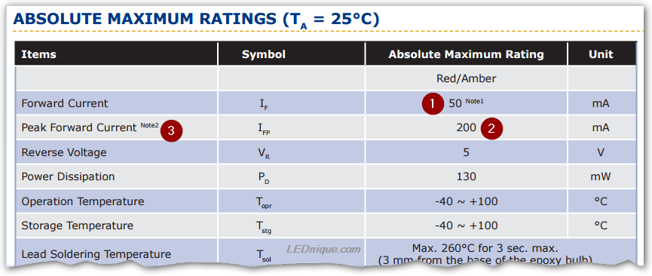

Extract from Cree 5mm round LED C503 datasheet.

Maximum continuous forward current is 50 mA (1).
Peak forward current is quoted at 200 mA (2).

